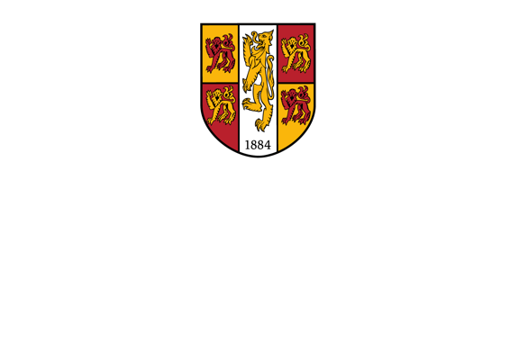

**Gender Pay Gap Report**

**2024**

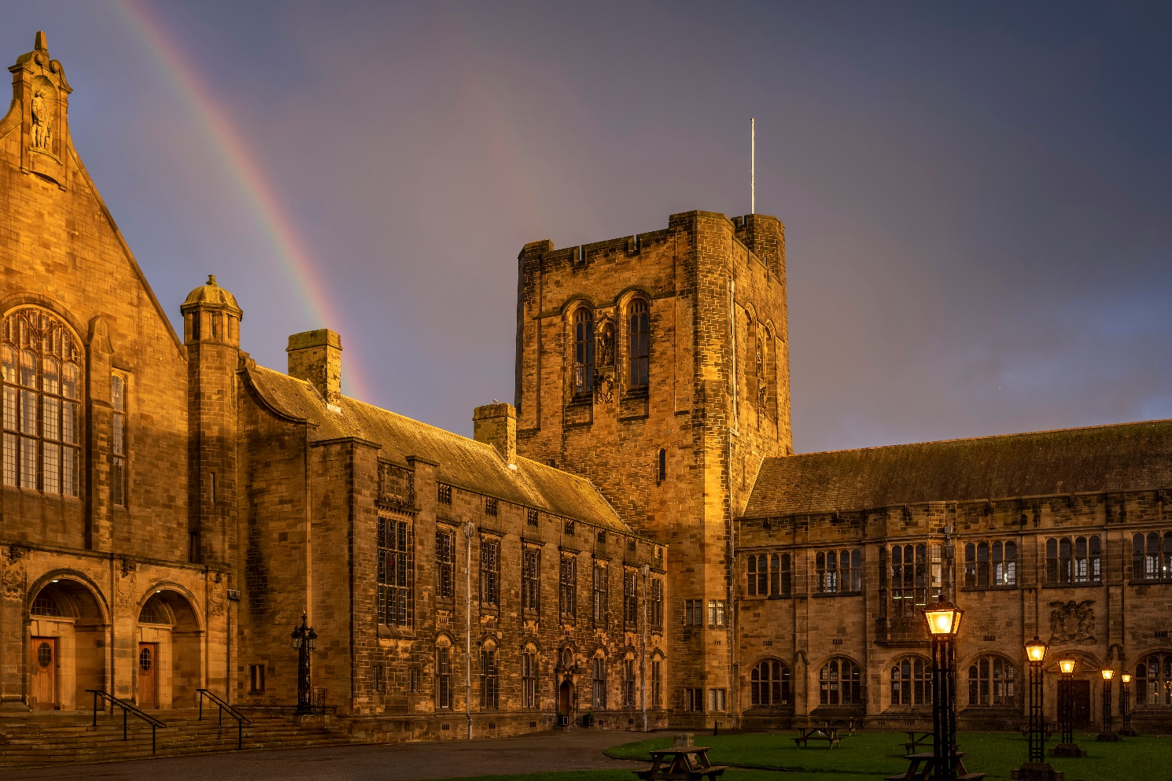

**Data from snapshot date of 31 March 2024**

**Published March 2025**



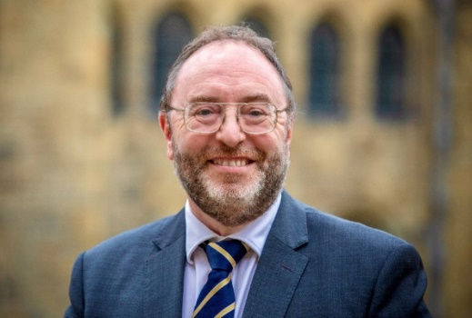

At Bangor University, we are committed to equality, diversity and inclusivity. As outlined in Strategy 2030, we will continue to work towards advancing equality of opportunity and supporting staff to thrive in an inclusive, diverse, bilingual workplace.

This Gender Pay Gap Report 2024 provides insight into our continued effort towards meeting this commitment. In the current reporting period, our median gender pay gap has been maintained at 5.7%. This remains lower than the UK figure (7%) and lower than the UK HE sector figure (9%) for the 7th successive year. However, we acknowledge that a gap still exists, and we are focused on further reducing our pay disparities.

The primary factor that contributes to our gender pay gap continues to be the underrepresentation of women in our most senior grades. We remain committed to providing targeted opportunities to female colleagues to retain, develop and progress their careers within Bangor University, and we continue to see excellent uptake with these opportunities, alongside positive feedback from our staff.

There is, however, a decrease in female staff at Senior level from 30.4% in 2023 to 27.6% in this reporting year. The increase in our institutional mean gender pay gap for this reporting year demonstrates the need for a continued commitment to address vertical segregation in the University, through the identification of influencing factors, and the continued development and review of the University’s action plan to address the Gender Pay Gap.

Identifying and removing barriers to progress for staff from all backgrounds is key to our equalities work at Bangor University and we continue to report our institutional-level Ethnicity and Disability Pay Gaps. In October 2023, we gained Disability Confident Employer level 2 accreditation, and in 2024, we obtained the Athena Swan Silver award and the Race Equality Charter Bronze award.

Our charter action plans commit to a range of activities to enhance the University’s understanding of intersectional inequalities, eliminate the opportunities for racial and gender-based bias and reduce inequalities in experience and outcomes for staff. Combined with the Gender Pay Gap Action Plan at the end of this report, the significant work around our Athena Swan and Race Equality Charters will support us in meeting the objectives outlined in our strategy, helping to shape our organisation into a truly inclusive and representative place to work.

**Professor Edmund Burke**

Vice-Chancellor

1. **INTRODUCTION**
   1. Following on from discussions of the Equal Pay Working Group and as agreed with the Trades Unions as part of that group, the University is voluntarily publishing its Gender Pay Gap.
   2. The Gender Pay reporting requirements have now been in force since 6 April 2017 and cover individuals employed under a contract of employment (including apprenticeships) on a snapshot date.  The snapshot is based on pay in the ‘pay period’ within which the ‘relevant date’ falls.  The relevant date is 5 April annually, however for public bodies the date is 31 March.  As the University pays its employees on a monthly basis, this would therefore be the March pay.  Government guidance requires that employees paid a reduced rate on the snapshot date e.g. reduced maternity leave, sick leave, are excluded from the calculations.
   3. Details of the University’s Gender Pay Gap will be published on our own website and on the [Government’s Equalities Office web site](https://gender-pay-gap.service.gov.uk/?_ga=2.52154537.1039239635.1704466223-414597203.1687610732) by 30 March annually.
   4. In addition to this Gender Pay Gap Report, the University regularly conducts an Equal Pay audit. It is important to understand that a Gender Pay Gap is not the same as Equal Pay
      * + **Equal Pay** looks at the pay differences between male and female employees who undertake the same job, similar jobs, or work of equal value.
        + **Gender Pay** looks at the difference between the average earnings of male and female employees across the entire University. It therefore shows the distribution of male and female employees across the entire University salary range.
   5. The University is voluntarily publishing details of its Ethnicity Pay Gap and Disability Pay Gap.  To protect anonymity, data is currently presented at Institutional level only and not by quartile pay bands.
2. **COVERAGE**
   1. Gender Pay Gap reporting requirements do not apply to public authorities within Wales, however, as the University is committed to equality of opportunity and transparency, we have decided to publish details of our Gender Pay Gap in line with the Equality Act 2010 (Specific Duties and Public Authorities) Regulations 2017, which are mandatory in England.
   2. The data covers all individuals employed by the University as of 31 March 2024.  Any employees not receiving their full basic pay for reasons such as maternity leave, parental leave, sick leave, special leave, career break are excluded. Where individuals held more than one job they have been counted separately for each job.
   3. Data is analysed on the basis of hourly pay.  For the purpose of Gender Pay Gap analysis hourly pay is basic hourly pay plus qualifying additional pay e.g. guaranteed allowances, first aid payments etc.
   4. In addition to top level institution analysis, the data has also been analysed by the following Employee Categories – Academic & Research, Managerial & Professional, Technical, Administrative & Clerical, and Manual.
   5. Gender pay gap data has been analysed as the percentage difference using the male salary as the base. A **positive** percentage figure indicates female employees have lower pay than male employees.  A **negative** percentage figure indicates male employees have lower pay than female employees.
   6. Since 2020 the University has included the analysis and publication of its Institutional-level Ethnicity pay gap. Data has been analysed as the percentage difference using the White employee salary as the base. A **positive** percentage figure indicates that minoritised ethnic (ME) employees have lower pay than White employees. A **negative** percentage figure indicates White employees have lower pay than ME employees.
   7. Since 2021 the University has also included the analysis and publication of its Institutional-level Disability Pay Gap. Data has been analysed as the percentage difference using the non-disabled salary as the base. A **positive** percentage figure indicates disabled staff are in receipt of lower pay, in comparison to non-disabled staff.
3. **FINDINGS**

Data has been analysed as follows:

|  |
| --- |
| * **% difference in median pay between female and male employees** |

|  |
| --- |
| * **% difference in mean and median bonus payment, plus proportion of female and males who received bonus payment** |

|  |
| --- |
| * **% difference in mean pay between female and male employees** |

|  |
| --- |
| * **Number of female and male employees according to quartile pay bands** |

|  |
| --- |
| * **Female and male employees according to grades** |

|  |
| --- |
| * **% difference in median pay between minoritised ethnic and white employees** |

|  |
| --- |
| * **% difference in mean pay between minoritised ethnic and white employees** |

|  |
| --- |
| * **% difference in median pay between those employees who identify as disabled and employees who do not identify as disabled** |

|  |
| --- |
| * **% difference in mean pay between those employees who identify as disabled and employees who do not identify as disabled** |

**TABLE 1.1 INSTITUTION OVERVIEW**

Table 1.1. provides an institutional overview covering each of the areas indicated in **3. Findings** above

(with the exception of grade analysis that follows in table 1.7)

|  |  |  |  |  |  |  |
| --- | --- | --- | --- | --- | --- | --- |
| **Mean Gender Pay Gap** | Female Mean    = | £ 20.96 | Male Mean = | £24.40 | Variance = | **14.1%** |
| **Median Gender Pay Gap** | Female Median = | £ 20.79 | Male Median | £ 22.05 | Variance = | **5.7 %** |
| Mean Bonus Gender Pay Gap | Female Mean    = | £0.00 | Male Mean = | £0.00 | Variance = | **0.0 %** |
| Median Bonus Gender Pay Gap | Female Median = | £0.00 | Male Median = | £0.00 | Variance = | **0.0%** |
| Proportion of males receiving bonus payment |  |  | Male = | 0% |  |  |
| Proportion of females receiving bonus payment | Female = | 0% |  |  |  |  |
| **Mean Ethnicity Pay Gap** | Minoritised Ethnic = | £ 24.00 | White = | £ 22.10 | Variance = | **- 7.9%** |
| **Median Ethnicity Pay Gap** | Minoritised Ethnic = | £ 21.70 | White = | £ 20.99 | Variance = | **-3.3%** |
| **Mean Disability Pay Gap** | Identified as Disabled = | £ 19.88 | Not Identified Disabled = | £ 22.83 | Variance = | **12.9%** |
| **Median Disability Pay Gap** | Identified as Disabled = | £ 18.48 | Not Identified Disabled = | £ 22.05 | Variance = | **16.2%** |
|  | | | | | | |
| **Proportion of Males and Females in each quartile pay band** | | | | | | |
| Of the 480 employees in the lower quartile, 178 are male and 302 are female. This means 37.1% are male and 62.9% are female. | | | | | | |
| Of the 480 employees in the lower middle quartile, 162 are male and 318 are female. This means 33.8% are male and 66.2% are female. | | | | | | |
| Of the 480 employees in the upper middle quartile, 170 are male and 310 are female. This means 35.4% are male and 64.6% are female. | | | | | | |
| Of the 480 employees in the upper quartile, 248 are male and 232 are female. This means 51.7% are male and 48.3% are female. | | | | | | |



**PROPORTION OF MALES AND FEMALES IN EACH QUARTILE PAY BAND**



1. It is evident from Table 1.1. that there continues to be a Gender Pay Gap at Institutional level with male employees’ median pay being **5.7%** higher than female employees’ pay, and male mean pay being **14.1%** higher than the mean pay of female employees.
2. Bangor University’s median gender pay gap at 5.7% remains lower than the UK national median gender pay gap for which the [Gender pay gap in the UK - Office for National Statistics](https://www.ons.gov.uk/employmentandlabourmarket/peopleinwork/earningsandworkinghours/bulletins/genderpaygapintheuk/2024) indicates a median pay gap of 7% across all employees.
3. [Equality in higher education: staff statistical report 2024 | Advance HE](https://www.advance-he.ac.uk/news-and-views/equality-higher-education-staff-statistical-report-2024) reported a median gender pay gap of 9% across all Higher Education Institutions in the 2022 - 2023 academic year, and the mean gender pay gap was 13.7%
4. Bangor University has continued to perform favourably in comparison to the ONS (whole economy) and Advance HE (HEI employees) median gender pay gap statistics for the 7th year in succession.
5. Whilst the number of female employees continues to outnumber male employees at Bangor University (60.5% of the workforce being female, 39.5% male on the snapshot date), the overall Gender Pay Gap for the University (5.7% Median) reflects the proportion of male staff in higher paid roles at the University, in comparison to their female colleagues.
6. In line with UCEA guidance, Clinical Excellence Awards are classified as bonus pay. Clinical Excellence Awards are awarded by the NHS and are therefore out of the control of the University.
7. To understand the data, further analysis was also undertaken by job families as can be seen in Tables 1.2, 1.3, 1.4, 1.5 and 1.6.
8. Data in Table 1.1. indicates a positive Ethnicity Pay Gap in favour of minoritised ethnic employees, with mean pay being 7.9% higher than white employees and median pay being 3.3% higher for minoritised ethnic employees.

Minoritised ethnic staff represented 9.6% of the University’s workforce during the reporting period, a 1.3% increase from the previous reporting year. The majority of minoritised ethnic employees (70.1%) were employed in posts in grades 6 to 9, in comparison to 66.5% of their White peers. 25.5% of minoritised ethnic staff occupied positions that range between Grade 1 and 5, in comparison to 27.9% of White staff.

1. The Disability Pay Gap, as shown in Table 1.1. indicates a mean variance of 12.9% and median of 16.2% in favour of staff who do not identify as disabled. This year’s mean disability pay gap has decreased by 0.6% from last year’s figures of 13.5%. This year’s median disability pay gap has increased by 0.3% from last year’s median of 15.9%. In 2021, the first year of reporting, it was mean 12.9%, median 16.8%.

Staff who identify as disabled represent 10.8%, a slight decrease from the previous year reporting figure of 11.2% of the University’s workforce in 2023. Of these staff 57% are employed at Grade 6 or below. it is notable that 13.6% of staff either prefer not to state, or do not state whether they identify as disabled or not.

**TABLE 1.2 ACADEMIC & RESEARCH STAFF OVERVIEW**

|  |  |  |  |  |  |  |  |  |  |
| --- | --- | --- | --- | --- | --- | --- | --- | --- | --- |
| **Mean Gender Pay Gap** | Female Mean    = | | £25.34 | | | Male Mean = | £ 29.42 | Variance =13.9 | % |
| **Median Gender Pay Gap** | Female Median = | | £23.40 | | | Male Median = | £26.81 | Variance =12.7 | % |
| Mean Bonus Gender Pay Gap | Female Mean    = | | £0.00 | | | Male Mean = | £0.00 | Variance = | 0.0% |
| Median Bonus Gender Pay Gap | Female Median = | | £0.00 | | | Male Median = | £0.00 | Variance = | 0.0% |
| Proportion of males receiving bonus payment |  | |  | | | Male = | 0% |  |  |
| Proportion of females receiving bonus payment | Female = | 0% | |  |  |  | |  | |
| **Proportion of Males and Females in each quartile pay band** | | | | | | | | | |
| Of the 231 employees in the lower quartile, 79 are male and 152 are female. This means 34.2% are male and 65.8% are female. | | | | | | | | | |
| Of the 230 employees in the lower middle quartile, 86 are male and 144 are female. This means 37.4% are male and 62.6% are female. | | | | | | | | | |
| Of the 230 employees in the upper middle quartile, 94 are male and 136 are female. This means 40.9% are male and 59.1% are female. | | | | | | | | | |
| Of the 230 employees in the upper quartile, 137 are male and 93 are female. This means 59.6% are male and 40.4% are female. | | | | | | | | | |

**PROPORTION OF MALE AND FEMALE ACADEMIC & RESEARCH EMPLOYEES IN EACH QUARTILE PAY BAND**

There continues to be a variance in both the mean and median gender pay gaps for this category of staff. This year’s mean pay gap of 13.9% is a 4% increase on the previous reporting year figure of 9.9% (11.3% in 2022). The median gap of 12.7% is also an increase of the previous years figure of 11.7% (13.6% in 2022).

Further analysis of the data demonstrates there are 4.2% fewer female staff occupying Upper Quartile Academic and Research roles (40.4%) in this reporting year than in the previous ( 44.6% in 2023, 40.5% in 2022, 38% in 2021). This reduced representation will negatively impact the gender pay gap for this job category.

Of the 33 successful professor and readers applications for promotion in 2023, 42% were female (n 14). The mean academic gender pay gap here is impacted by the amount male academics whose hourly rate is affected by market supplement, clinical scaling or whose salaries fall outside of grades.

Overall, the Academic and Research category comprises 57% female staff (55.9% in 2023) and 43% male staff (44.1% in 2023), with the greatest gender imbalance (65.8% in favour of females) evidenced in the Lower Quartile.

|  |  |  |  |  |  |  |
| --- | --- | --- | --- | --- | --- | --- |
| **Mean Gender Pay Gap** | Female Mean    = | £ 23.60 | Male Mean = | £ 30.31 | Variance = 22.1 | % |
| **Median Gender Pay Gap** | Female Median = | £ 22.05 | Male Median = | £ 25.38 | Variance = 13 | % |
| Mean Bonus Gender Pay Gap | Female Mean    = | £0.00 | Male Mean = | £0.00 | Variance = | 0.0% |
| Median Bonus Gender Pay Gap | Female Median = | £0.00 | Male Median = | £0.00 | Variance = | 0.0% |
| Proportion of males receiving bonus payment |  |  | Male = | 0% |  |  |
| Proportion of females receiving bonus payment | Female = | 0% |  |  |  |  |
| **Proportion of Males and Females in each quartile pay band** | | | | | | |
| Of the 72 employees in the lower quartile, 16 are male and 56 are female. This means 22.2% are male and 77.8% are female. | | | | | | |
| Of the 72 employees in the lower middle quartile, 20 are male and 52 are female. This means 27.8% are male and 72.2% are female. | | | | | | |
| Of the 72 employees in the upper middle quartile, 26 are male and 46 are female. This means 36.1% are male and 63.9% are female. | | | | | | |
| Of the 72 employees in the upper quartile, 40 are male and 32 are female. This means 55.6% are male and 44.4% are female. | | | | | | |

**TABLE 1.3 MANAGERIAL & PROFESSIONAL STAFF OVERVIEW**

**PROPORTION OF MALE AND FEMALE MANAGERIAL & PROFESSIONAL EMPLOYEES IN EACH QUARTILE PAY BAND**

Analysis of the Managerial and Professional category as a whole identifies that 64.6% of the staff are female, and they are, in the majority, in the Lower and Lower Middle Quartiles. There has been a 2.1% increase in the Upper Middle quartile this year. The number of females in the Upper Quartile has slightly decreased from 45.2% in 2023 to 44.45 in this reporting year (45.1% female in 2022).

There continues to be a higher proportion of female staff in the lower quartiles leading to the mean gender pay gap value being maintained in this reporting period at 22.1% (22% in 2023 and 17% in 2022) and the highest mean pay gap across all job categories.

The Median gender pay gap value has decreased from 15.5% in 2023 to 13% in this reporting period (13.7% in 2022).

Despite the decrease in median pay gap for this job category, the number of males in the Senior Staff roles, these are Director and Executive level roles, has increased slightly to 70.4% this year compared with 69.6% in 2023 (68.4% in 2022 and 58.8% in 2021) and the hourly rate for these roles is affected by market led salaries outside of BU pay scales.

|  |  |  |  |  |  |  |
| --- | --- | --- | --- | --- | --- | --- |
| **Mean Gender Pay Gap** | Female Mean    = | £ 14.63 | Male Mean = | £15.51 | Variance = 5.7 | % |
| **Median Gender Pay Gap** | Female Median = | £ 14.03 | Male Median = | £ 15.12 | Variance = 7.3 | % |
| Mean Bonus Gender Pay Gap | Female Mean    = | £0.00 | Male Mean = | £0.00 | Variance = | 0.0% |
| Median Bonus Gender Pay Gap | Female Median = | £0.00 | Male Median = | £0.00 | Variance = | 0.0% |
| Proportion of males receiving bonus payment |  |  | Male = | 0% |  |  |
| Proportion of females receiving bonus payment | Female = | 0% |  |  |  |  |
| **Proportion of Males and Females in each quartile pay band** | | | | | | |
| Of the 26 employees in the lower quartile, 18 are male and 8 are female. This means 69.2% are male and 30.8% are female. | | | | | | |
| Of the 26 employees in the lower middle quartile, 15 are male and 11 are female. This means 57.7 % are male and 42.3% are female. | | | | | | |
| Of the 27 employees in the upper middle quartile, 20 are male and 7 are female. This means 74.1% are male and 25.9% are female. | | | | | | |
| Of the 26 employees in the upper quartile, 21 are male and 5 are female. This means 80.8% are male and 19.2% are female. | | | | | | |

**TABLE 1.4 TECHNICAL STAFF OVERVIEW**

**PROPORTION OF MALE AND FEMALE TECHNICAL EMPLOYEES IN EACH QUARTILE PAY BAND**

Male staff representation is higher across all quartiles in this job category, with the highest female representation at the Lower Middle Quartile. The number of female staff in Technical roles has decreased from 32% in 2023 to 29.5% in this reporting year. This compares with 27.5% in 2022 and 24.2% in 2021.

The mean gender pay variance has decreased significantly from 9.1% in 2023 to 5.7% in this reporting period. The median gender pay variance has also seen a notable decrease from 10.8% last year to 7.3%.

Female representation in the Upper Quartile has significantly increased from 13.3% in 2023 to 19.2% in this reporting year. The proportion of females in all other quartiles has decreased from the previous year. Female representation in the Lower Quartile continues to decrease from 33.35% in 2023 to 30.8% in this reporting period, from 51.6% to 42.2% in the Lower Middle Quartile and from 29% to 25.9% in the Upper Middle Quartile.

|  |  |  |  |  |  |  |
| --- | --- | --- | --- | --- | --- | --- |
| Mean Gender Pay Gap | Female Mean    = | £ 15.94 | Male Mean = | £ 15.81 | Variance = | -0.8% |
| Median Gender Pay Gap | Female Median = | £ 14.42 | Male Median = | £14.25 | Variance = | -1.2% |
| Mean Bonus Gender Pay Gap | Female Mean    = | £0.00 | Male Mean = | £0.00 | Variance = | 0.0% |
| Median Bonus Gender Pay Gap | Female Median = | £0.00 | Male Median = | £0.00 | Variance = | 0.0% |
| Proportion of males receiving bonus payment |  |  | Male = | 0% |  |  |
| Proportion of females receiving bonus payment | Female = | 0% |  |  |  |  |
| **Proportion of Males and Females in each quartile pay band** | | | | | | |
| Of the 96 employees in the lower quartile, 24 are male and 72 are female. This means 25% are male and 75% are female. | | | | | | |
| Of the 96 employees in the lower middle quartile, 14 are male and 82 are female. This means 14.6% are male and 85.4% are female. | | | | | | |
| Of the 96 employees in the upper middle quartile, 23 are male and 73 are female. This means 24% are male and 76% are female. | | | | | | |
| Of the 95 employees in the upper quartile, 16 are male and 79 are female. This means 16.8% are male and 83.2% are female. | | | | | | |

**TABLE 1.5 ADMINISTRATIVE & CLERICAL STAFF OVERVIEW**

**PROPORTION OF MALE AND FEMALE ADMINISTRATIVE & CLERICAL EMPLOYEES IN EACH QUARTILE PAY BAND**

Female role holders continue to dominate all quartiles within the Administrative & Clerical category, currently representing 79.9% of the staff in this job category (72.9% of this category the previous year).

The Upper Quartile has seen an increase in female staff from 75.9% last year to 83.2% this year. Accordingly the proportion of males has decreased from 24.1% in 2023 to 16.8% in this reporting year.

The Mean and Median gender pay variances have both increased with a gap in favour of female staff. Both values stood at 0% for the Administrative & Clerical category of staff in 2023, whilst the mean and median for this reporting period are -0.8% and -1.2% respectively.

**TABLE 1.6:  MANUAL STAFF OVERVIEW**

|  |  |  |  |  |  |  |
| --- | --- | --- | --- | --- | --- | --- |
| Mean Gender Pay Gap | Female Mean    = | £ 11.65 | Male Mean = | £12.52 | Variance = 6.9 | % |
| Median Gender Pay Gap | Female Median = | £ 11.08 | Male Median = | £11.67 | Variance = 5.1 | % |
| Mean Bonus Gender Pay Gap | Female Mean    = | £0.00 | Male Mean = | £0.00 | Variance = | 0.0% |
| Median Bonus Gender Pay Gap | Female Median = | £0.00 | Male Median = | £0.00 | Variance = | 0.0% |
| Proportion of males receiving bonus payment |  |  | Male = | 0% |  |  |
| Proportion of females receiving bonus payment | Female = | 0% |  |  |  |  |
| **Proportion of Males and Females in each quartile pay band** | | | | | | |
| Of the 56 employees in the lower quartile, 25 are male and 31 are female. This means 44.6% are male and 55.4% are female. | | | | | | |
| Of the 55 employees in the lower middle quartile, 20 are male and 35 are female. This means 36.4% are male and 63.6 % are female. | | | | | | |
| Of the 55 employees in the upper middle quartile, 20 are male and 35 are female. This means 36.4% are male and 63.6% are female. | | | | | | |
| Of the 55 employees in the upper quartile, 38 are male and 17 are female. This means 69.1% are male and 39.9% are female. | | | | | | |

**PROPORTION OF MALE AND FEMALE MANUAL EMPLOYEES IN EACH QUARTILE PAY BAND**

There has been a reduction in overall number of staff in this job category on the snapshot date in this reporting period. There is greater female representation across Lower and Upper Middle Quartiles in this reporting year and a notable decrease in female representation in the Upper Quartile for this job category, with female staff representing 39.1% compared with the 43.9% figure in 2023.

There has been a 4.6% increase in female representation in the Lower Quartile and 4.8% decrease in female representation in the Upper Quartile in this reporting period compared to the previous year (50.8% female in Lower Quartile in 2023, 43.9% female in the Upper Quartile in 2023).

The Mean gender pay variance has significantly increased, from 3.3% last year to 6.9% in this reporting year (5.1% in 2022, 5.4% in 2021, and 6% in 2020).

The Median gender pay variance has significantly increased from 1.6% last year to 5.1% in this reporting year (2.7% in 2022 from 1.8% in 2021 8.7% in 2020).

**TABLE 1.7 ALL EMPLOYEES**

**PROPORTION OF MALES AND FEMALES IN EACH GRADE**

Analysis by grade reveals that the Gender Pay Gap at Bangor University is primarily due to the under-representation of female employees in senior roles within the University. There has been no increase in the representation of female staff at professorial level and a year-on-year increase in the numbers of males in the Senior Staff roles (Director and Executive level roles in Professional Services) with an increase to 72.4% in this reporting year from 69.6% in 2023, 68.4% in 2022 and 58.8% in 2021. There is a decrease in female staff at Senior level from 30.4% in 2023 to 27.6% in this reporting year.

Female representation continues to be highest in Grade 5 at 72.4%; an increase from 69.9% in 2023.

There has been a continued and significant increase in occupancy of female staff in Grade 1 positions, from 63% in 2023 to 69.2% in this reporting year.

There is a notable increase in female staff at Grade 7, up from 63.9% in 2023 to 68.4% in the current reporting year and, at Grade 9 from 43.5% in 2023, to 46.8% this reporting year.

The numbers of females compared with males at Grade 8 has decreased this year to 57.2% following a year-on-year increase; compared with the continued increases from 2021 (54.3%) to 2022 (56.3%) and 59.2% in 2023.



1. **SUMMARY**
2. It is important to highlight that a Gender Pay Gap is different to that of an Equal Pay Gap. Under Equal Pay, comparisons are made between male and female employees being employed to carry out the same role, similar roles, or work of equal value.  This level of analysis is covered by the Equal Pay Audit.
3. A Gender Pay Gap differs in that it demonstrates the differences in the average pay between male and female employees, regardless of their role/equal value. It identifies whether lower paid jobs are more likely to be filled by female employees than male employees.  A high Gender Pay Gap does not mean that male and female employees are not being paid equally for doing like work or work of similar value.
4. Whilst Bangor University’s median Gender Pay Gap, at 5.7%, is smaller than the UK national median Gender Pay Gap (7%), a gap still exists.
5. This year’s mean Gender Pay Gap, at 14.1%, demonstrates the need for a continued commitment to address vertical segregation in the University, through the identification of influencing factors, and the continued development and review of the University’s action plan to address the Gender Pay Gap.
6. In the Administrative and Clerical job category, both the Mean and Median gender pay variances evidence a positive gap in favour of female staff pay.
7. The job category where we see the highest Gender Pay Gap at Bangor University is in that of Managerial & Professional staff with a mean gender pay gap of 22.1% and median gender pay gap of 13%, both in favour of males however this is a slight reduction in variance from the previous reporting year.
8. The University may wish to take ‘positive action’, permitted under the Equality Act, to help address areas of concern, if it believes employees/job applicants are:

* At a disadvantage because of their sex, and/or
* Are under-represented in the organisation, or whose participation in the organisation is disproportionately low, because of their sex and/or
* Have specific needs connected to their sex.

If ‘positive action’ is taken, the University must show specific evidence that any positive action is both reasonably considered, appropriate and will not discriminate against others.

1. At present (and to protect anonymity), the Ethnicity Pay Gap data has been presented at Institutional level only. The data indicates a Mean variance of -7.9% and a Median variance of

-3.3% (a minus figure is in favour of minoritised ethnic employees).

1. Disability Pay Gap data has also been presented at Institutional level only. Data indicates a Mean variance of 12.9% and a Median of 16.2%, both in favour of employees who have not identified as disabled. Staff who preferred not to state whether they identified as disabled, or who did not provide a response at all, represent 13.6% of the total workforce.
2. Of the equality characteristics measured at an institutional level (gender, disability and ethnicity), the Disability Pay Gap is the highest at mean 12.9%, median 16.2% both in favour of non-disabled employees.



1. It is worth noting that Bangor University does not outsource its manual roles and continues to facilitate these positions in house (e.g. domestic cleaning staff, security, catering).  All these roles are included within this Gender Pay Gap Report.



1. **PROGRESS AND ACTION PLAN TO REDUCE THE GENDER PAY GAP**

The **Gender Pay Gap** is a long-standing societal concern, which is influenced by a number of factors relating to social pressures and norms, employer/institutional mandates/expectations, and family pressures. Due to the breadth of the subject, the University accepts it will only be able to influence some factors.

The University is a member of the **Athena Swan** Gender Equality Charter and achieved a **Silver institution-level award** in January 2024 in recognition of its support of, and continued work towards, gender equality. A commitment to addressing gendered occupational segregation and tackling the gender pay gap are key elements of the charter and as such a key priority in the Institutional Athena Swan Silver Action Plan.

In 2022 the University joined the **Race Equality Charter** and in November 2024, submitted an application for Bronze award. The institution’s 5-year Race Action Plan commits to a range of intersectional activity to enhance the university’s understanding of inequalities for staff and students and, eliminate the opportunities for racial and gender-based bias, and reduce inequalities in experience and outcomes for staff and students.

As part of our Advance HE joint charter work going forward, the University will voluntarily carry out an intersectional pay gap analysis to explore if and where there are intersectional factors affecting pay gaps at an institutional level; using this to further enhance our Athena Swan and Race Equality work.

As supported by our data, it is evident that the primary influencing factor on the University’s Gender Pay Gap, is the **under-representation of female employees** in the higher paid roles at the University.  Addressing this issue will take a number of years, however it is important that we reflect on the current initiatives in place to ensure they remain fit for purpose and continue to consider new initiatives which will help to address the Gender Pay Gap.  The University is committed to reducing its Gender Pay Gap, as is evident by the range of initiatives currently in place or being implemented:

**Career progression and development opportunities to address the gender pay gap**

* BU has signed up to Technician Commitment. This is a UK-wide initiative that "aims to ensure visibility, recognition, career development and sustainability for technicians working in higher education and research, across all disciplines". We became a signatory in Nov 2024.
* Equality, Diversity, and Inclusion underpin all our promotion and progression procedures.  We continue to review our promotion policies and procedures and other pay decisions, ensuring equality is reinforced at every opportunity.  The **promotions pathway** provides a platform to measure performance and respond accordingly to applications from a diverse range of fields, across the University.



* In 2024/25, the **Workload Allocation Model (WAM)** will be available to all schools. As part of its reporting functions, the model will provide data to compare employee workload allocations against certain protected characteristics, i.e. gender and ethnicity. Individual circumstances, including maternity leave, will also be considered, with guidance of increased time for research and scholarship in the first semester upon return, to support the principle of ensuring all employees are treated fairly and are given equal opportunities to develop to their full potential.
* Bangor University is committed to implementing the **Athena Swan Gender Equality Charter** and addressing the underrepresentation of women in Senior Leadership positions. We will continue to highlight and encourage participation with leadership and professional development opportunities (particularly for early and mid-career employees) to invest in our existing workforce and encourage progression and personal growth.
* In June 2024 we funded two places (one academic and one professional and support services) on the **Stellar HE** ***‘Strategic Development for Diverse Leaders’* programme**. In November 2024, two female ME members of staff were successful in gaining these places to take part in the February 2025 programme cohort.
* We continue to support women to access Advance HE’s **Aurora Leadership Programme** where possible. The programme is for female staff (up to senior lecturer level or the professional services equivalent) who wish to develop and explore issues relating to leadership roles and responsibilities.  Participants are paired with a senior mentor from the University who supports them throughout the programme.
* 25 female staff have completed the Aurora programme since 2020 when Bangor University initially funded places on this programme and we are committed to continue building attendance numbers, with a joint REC and AS action plan target to increase the participation of ME women in the programme through targeted recruitment communications. We have also supported three women to attend the Aurora mentoring workshop in 2024.



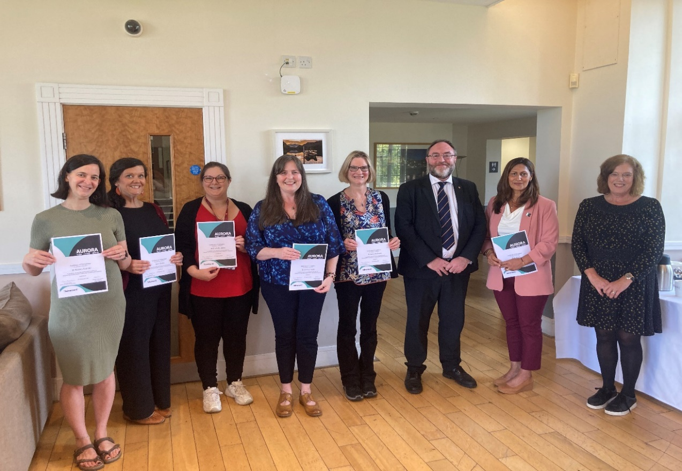

Aurora reception September 2024

* The **Academic Mentoring Scheme** enables staff who have three or more years of experience in an academic role to receive mentoring from more senior academics.
* Since its inception a higher proportion of females have consistently applied to be mentored. A total of 68 females have applied to the **Academic Mentoring Scheme** compared to 23 males. Furthermore, 43 females have applied to the**Senior Mentoring Scheme** compared to 15 males. A different pattern can be observed with the **HEA Fellowship Mentoring Scheme** with more males applying for support than females. We consistently see a higher number of females offering themselves as mentors compared to male members of staff also.

From a mentor:

*"It’s been an immense pleasure working with my mentee, watching how her thinking and work attitude developed over the year, and stepping out of my own area of expertise (and comfort zone) for these meetings"*

From a mentee:

*"As a mentee I received support and encouragement from a Senior member of staff outside of my discipline. This provided an opportunity to learn fresh perspectives and experiment with new ways of working. The scheme is efficiently run and is a great way to boost your personal and professional development."*



* The **Bangor Manager’s Programme** was launched in November 2021, with the initial cohort consisting of 27 staff, 19 of whom were female from roles ranging between grade 6 and 8 of the current pay scale and in both Professional and Academic positions.
* The programme enables participants to complete a selection of modules which have been designed to positively impact their personal management development journey e.g. Managing People, Managing in a Bilingual Environment, Recruitment and Selection training, Understanding Self and Others, and Equality & Diversity.
* Since it was introduced, 65 female members of staff have registered and have either completed or are part way through completion compared to 34 male members of staff. We have seen an increase in staff on grades 5 join the programme over the last 2 years (7 currently), these are male team leaders in Campus Services. This appears to be due to word of mouth from colleagues who have benefitted from the learning along with senior management in the service actively encouraging participation.
* The **Welsh Universities Research Leadership Programme** (WURLP) The programme has developed out of a collaborative project with Aberystwyth University (the Aber-Bangor Research Leadership Programme in 21/22 and 22/23) which has now been opened up to participants from other Welsh Universities. Across the 23/24 and 24/25 WURLP programmes, there have been 14 Bangor participants (8 female) It aims to enhance leadership capabilities by ensuring staff have the skills, abilities, and confidence to lead and manage research and research teams effectively. It also aims to improve Research and Leadership development opportunities for researchers in Wales by building strong, sustainable research communities across the country, a pledge which is echoed in Bangor University’s Research Strategy.
* The **Welsh Crucible** is an award-winning personal, professional and leadership development programme for early and mid-careers researchers that facilitates and promotes research-inspired innovation and cross-disciplinary collaboration in Wales. In 2024, three participants from Bangor University took part, all three were female.  Bangor has committed to again be part of the 2025 programme.
* In the coming year we will review the development opportunities listed above i.e. the Aurora Leadership Programme, the Academic Mentoring Scheme, the Bangor Management Programme, the Welsh Universities Research Leadership 23/24 Programme, and the Welsh Crucible from the perspective of whether these development programmes are self-selecting i.e. anyone can participate, or whether there is any kind of selection process. Where there is a selection process within Bangor University we will seek to vary and diversify who makes the decisions.

**Recruitment and reward**

We will continue to review and build on our inclusive recruitment and selection practices with a particular focus on ensuring that we reduce the impact of unconscious bias, protect against discrimination, and provide work and working environments that support both the needs and the progression of staff.

* We will be trialling **anonymous hiring across our professional services** in 2025 and scoping practice in HE of using this approach for entry level academic roles, in line with our Athena Swan and Race Equality action plans. We are exploring the possibility of asking applicants for senior academic positions to include equality statements in their applications.



* As part of our Disability Confident level 2 ‘Employer’ accreditation we will introduce a **guaranteed interview scheme** for applicants who identify as disabled and opt in to the scheme in 2025.
* We will work towards the use of **diverse recruitment panels** whenever possible and review the implementation of this requirement during the next 12 months.
* Where there is identified underrepresentation of female staff in a job category, we will use positive action statements in our recruitment practices to seek to address the increase in our institutional mean gender pay gap. And we will consider the use of positive action in recruitment where appropriate.
* During the previous Gender Pay Gap Action Plan we introduced additional checks in the event of a male, single-gender shortlist where there were applicants of mixed genders. Up to now we have not identified any all-male shortlists where the applicant pool was of mixed gender however, we will continue to undertake these checks within HR and encourage shortlisting panels to review the applications of all candidates to ensure no female candidates are overlooked.
* We will further review our **Interview Matrix** documentation to ensure consistency in interview process and detail of feedback for unsuccessful applicants.
* In 2020 we introduced a **Starting Salary Policy** and we will continue to monitor its use and review its effectiveness to ensure that the default position for new starters is that they start on the minimum of the pay band unless written justification based on skills and experience is provided.
* All vacant posts that are advertised are now available as **flexible/part-time/job-share opportunities** as the default offering, unless the recruiting manager provides justification where this is not suitable.

**Employee Support Policies**

* We continue to highlight our enhanced University **Paternity scheme** and University **Adoption scheme** rules, through the inclusion of these avenues in the HR induction presentation (available to all staff via Panopto recording) and by removing the requirement for a qualifying period, we have ensured all individuals who wish to do so, can benefit from the enhanced payments following their first day of employment.
* We will continue to offer a suite of **salary sacrifice** schemes including the opportunity to buy additional leave and childcare vouchers. In 2023, 79% of staff who opted to purchase annual leave were female. Regarding the purchase of childcare vouchers, within the same period of assessment, 60.5% of purchasers were female.

The results suggest the implementation of the referenced family friendly strategies are supporting females to succeed in the workplace. Whilst this is seen as a positive step to support females in the workplace, the University recognises the measure does not positively impact the Gender Pay Gap,

as in line with Government guidance, the resulting reduction in pay due to the purchase of the benefit, adversely impacts the volume of data which can be captured.

* Lower grade staff who are paid the Real Living Wage can be unable to access salary sacrifice to participate where that salary sacrifice takes them below the national minimum wage. This is a sector wide issue.

* We continue to promote the opportunity for flexible working through the implementation of the **Flexible Working Policy** and highlight the benefits, alongside **Shared Parental Leave**, in university-wide communications.
* In 2024 we introduced a new **Carers Leave Policy,** in line with the Carers Leave Act 2023, with staff taking Carer’s Leave afforded the same employment protections as associated with other forms of family related leave.
* We have implemented the opportunity for individuals to undertake **dynamic working** when possible and will continue to support this via a toolkit that helps the employee and line manager ascertain what is possible depending on the requirements of the role.
* The **Guide for Managers**, introduced in 2021, continues to be updated and used as a tool for communicating with managers important Employee Support Policies and Procedures. Recent updates include guidance on mandatory training for all staff.
* We continue to ensure that managers are aware of **maternity, paternity, adoption and shared parental leave policies, procedures**, and best practice regarding the management of employees prior, during and post maternity leave. We will consider how employees can be better supported on their return to work, in terms of managing workloads and getting their research career back on track.
* To support our staff with caring responsibilities, we will continue to advocate best practice for formal meetings to be held between 10am and 4pm.
* We will continue to offer a Menopause Toolkit that sets out a statement of support and includes a guidance document along with a range of information about perimenopause & the menopause to help managers support their staff. New staff induction sessions highlight the existence of the menopause lounge and toolkit.

**Employee Training**

* In December 2022 we introduced our Menopause Awareness for Line Managers training. Five training sessions have been delivered to 50 Line Managers so far from a variety of departments across the University, by our Occupational Health Practitioner and Health & Wellbeing Project Manager. Our Wellbeing Champions and Staff Wellbeing Coaches have also received Menopause Awareness training sessions (total 35 people) and are kept up to date about the menopause support available internally and how to access this.
* The **Unconscious Bias training** is mandatory for all staff as part of their induction and in the coming year we will consider how we can provide staff with refresher training opportunities.
* We continue to provide Equality training to all employees through our online e-learning package.
* Mandatory training includes Unconscious Bias and EDI courses which all staff must complete and review every two years has been introduced in 2024/25.

* Mandatory Equality training for Managers is delivered quarterly and customised Equality and Diversity training are delivered as required.
* Refresher training of relevant modules/courses was integrated into the current e-learning packages and launched in April 2023 in conjunction with the launch of the new HR system, to promote visibility and support the completion of primary and refresher training.
* In early summer 2025, we will be introducing two new bilingual*Introduction to Race Equality*E-Learning modules for all BU staff to access.